**Prerequisites**

OS Systems

* Windows 10
* Mac Mojave

Java IDE

* Eclipse IDE for Java Developers
* Version: 2019-12 (4.14.0)
* Build id: 20191212-1212
* OS: Windows 10, v.10.0, x86_64 / win32
* Java version: 13.0.2

**Environment Setup and Configurations**

* JUnit 4
* JRE System Library [JavaSE-13]

**Operations and the results**

The Start Screen

The initial display of the GUI should look like this. It consists of:

* Icon (Java default)
* Title: Chess Game
* Minimize, maximize/restore, close buttons
* Menu bar
* The Start Over button
* The standard starting position of a chessboard
  + Gray and white interchanging tiles, with a white tile on the left top corner
  + White pieces at bottom
  + Black pieces at top
  + Each side has a row of pawns at rank 2 and 7
  + Each side also has the following pieces on rank 1 and 8:
    - Rook on A and H
    - Knight on B and G
    - Bishop on C and F
    - Queen on D
    - King on E
  + Rank labels (1-8) on the side
  + File labels on the bottom (A-H)

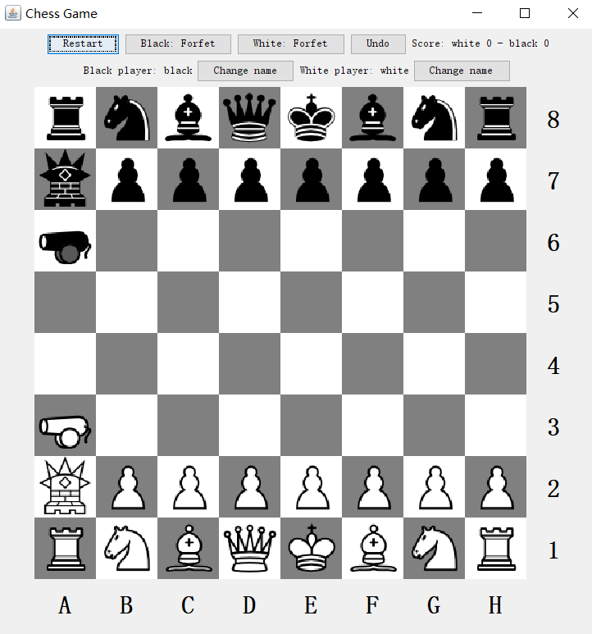

Move a piece

Move the pawn at F2 to F4. When a piece is clicked, it will be highlighted in blue. 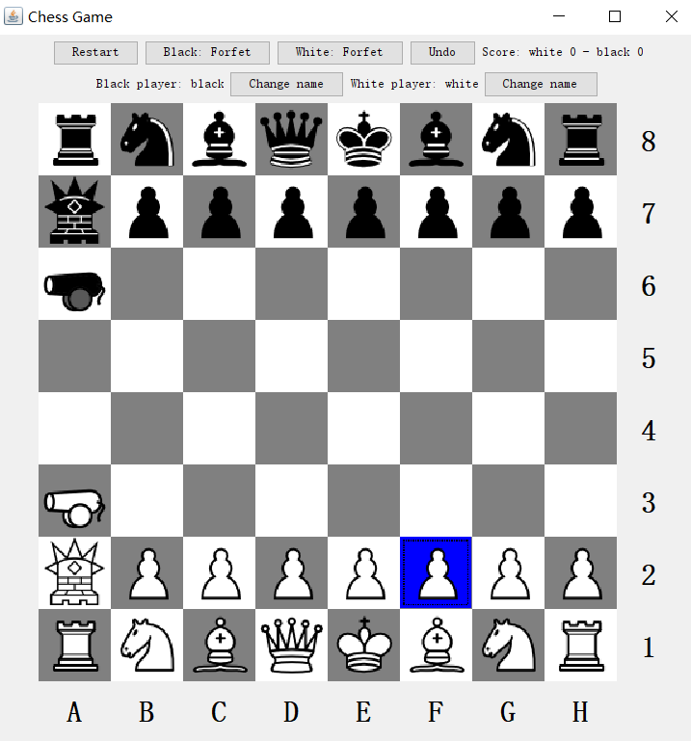

Then click on the gray tile at F4 to move the pawn.

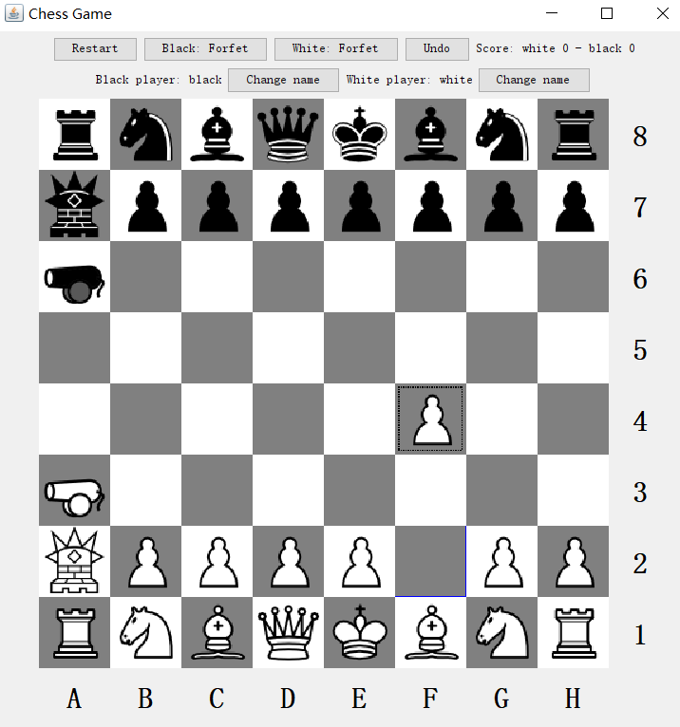

Checkmate

1. Move pawn at F2 to F4
2. Move pawn at E7 to E5
3. Move pawn at G2 to G4
4. The chessboard will look like the following.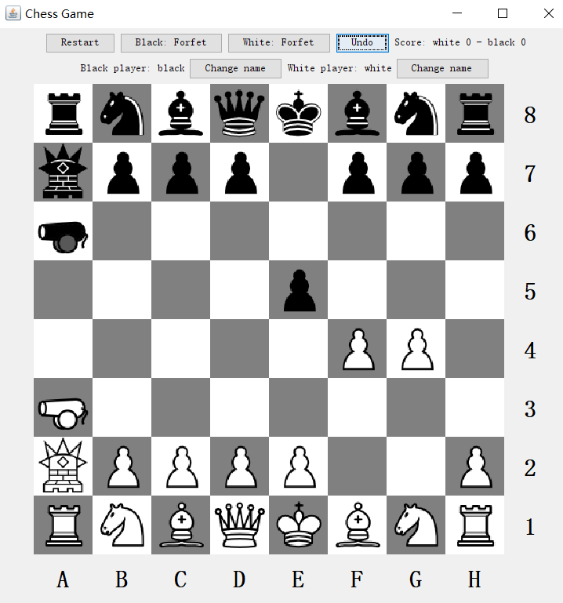
5. Move the queen from D8 to H4. Now the white king will be in checkmate, the game has ended, and black has won. A pop up window will appear to notify the players. 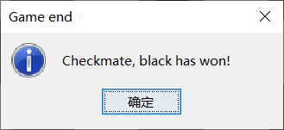
6. The score on the top right corner will also change. The board will be automatically set to a new game. 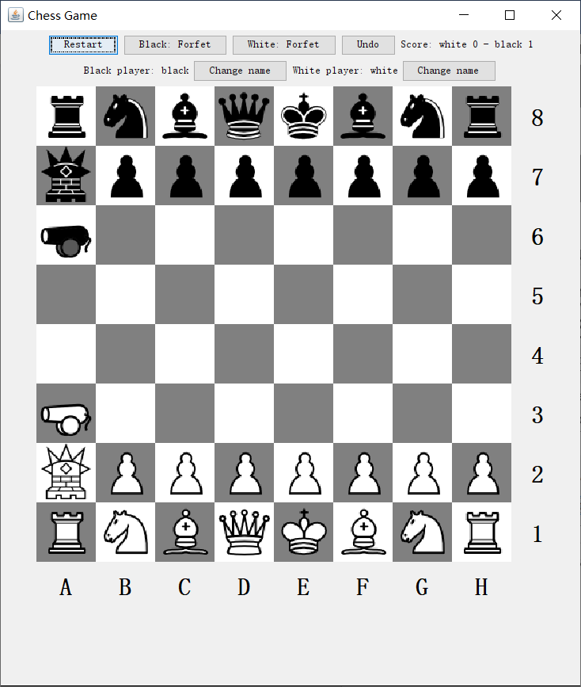

Forfeit a game

The white or black player can forfeit the game at anytime. By doing so, they automatically lose the game.

Click on the “Black forfeit” button, and a confirmation box will pop up: 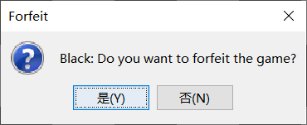 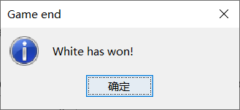

If clicked yes, white will won, the board will set up a new game, and the scores will change. 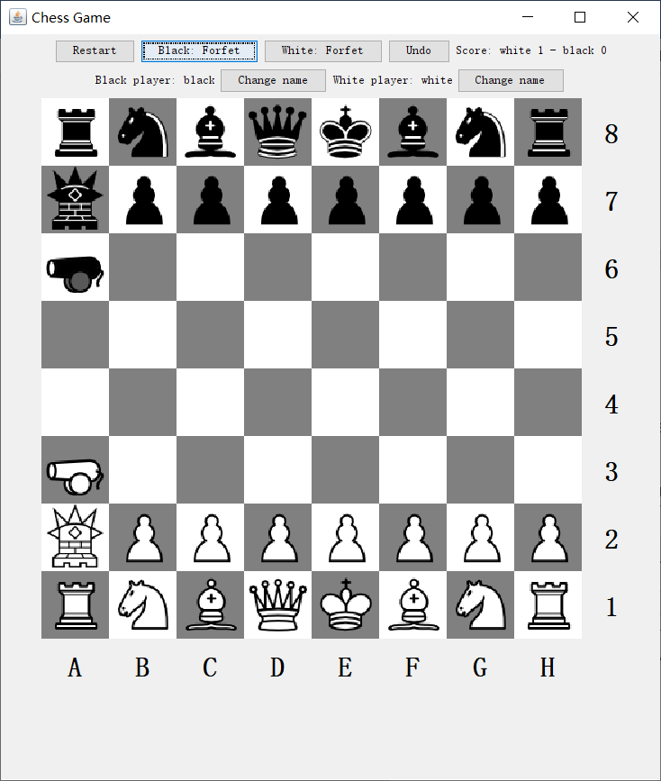

Undo

A player can undo the last move at anytime. If it’s white’s turn to move, black’s last move will undo. If it’s black’s turn, white’s last move will undo.

1. Move the pawn at E2 to E4
2. Move the pawn at F7 to F5
3. Move the pawn at E4 and F5 and capture. 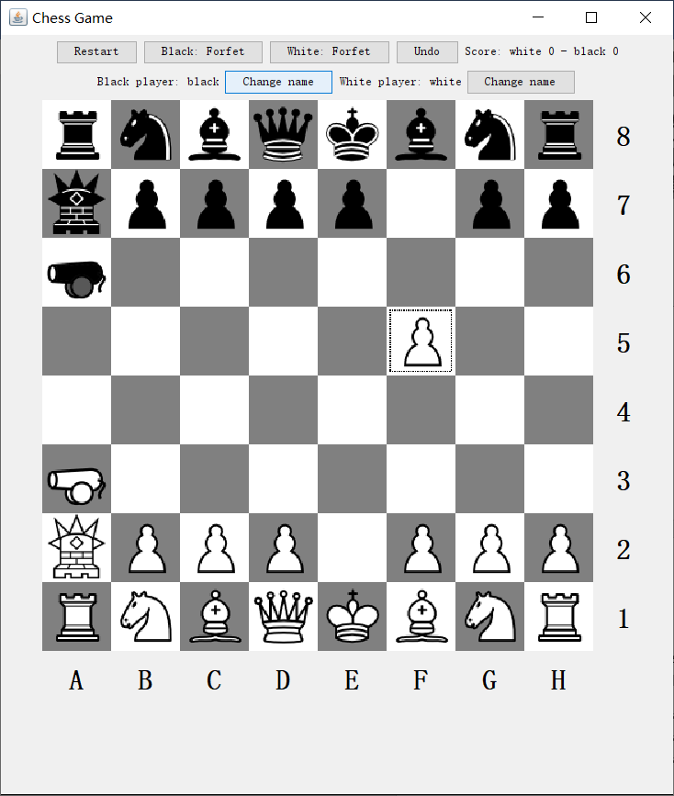
4. Click the Undo button once. White’s last move will be undone.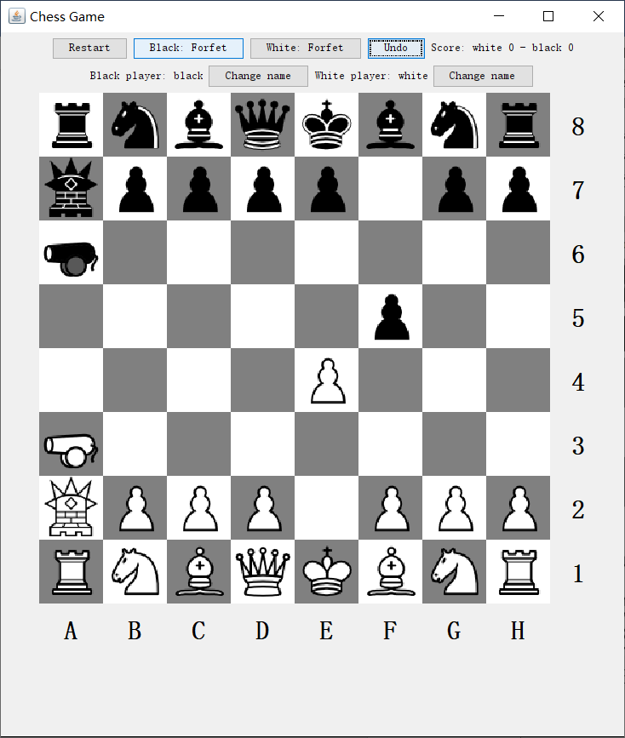
5. Click the Undo button again. Black’s last move will be undone. 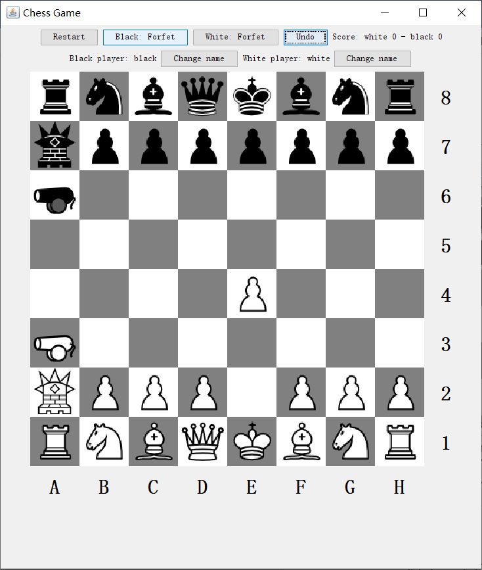

In Check

1. Move the pawn at E2 to E3.
2. Move the pawn at E7 to E6.
3. Move the pawn at F2 to F4. 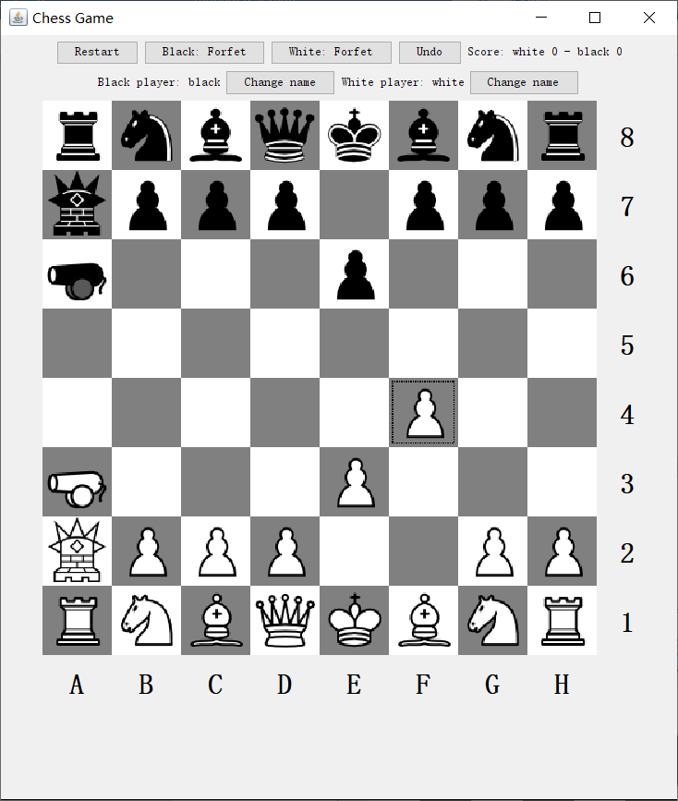
4. Move the queen at D8 to H4. Now the white king is in check, and a pop-up window will appear. However the game has not ended, and the white king can still escape. 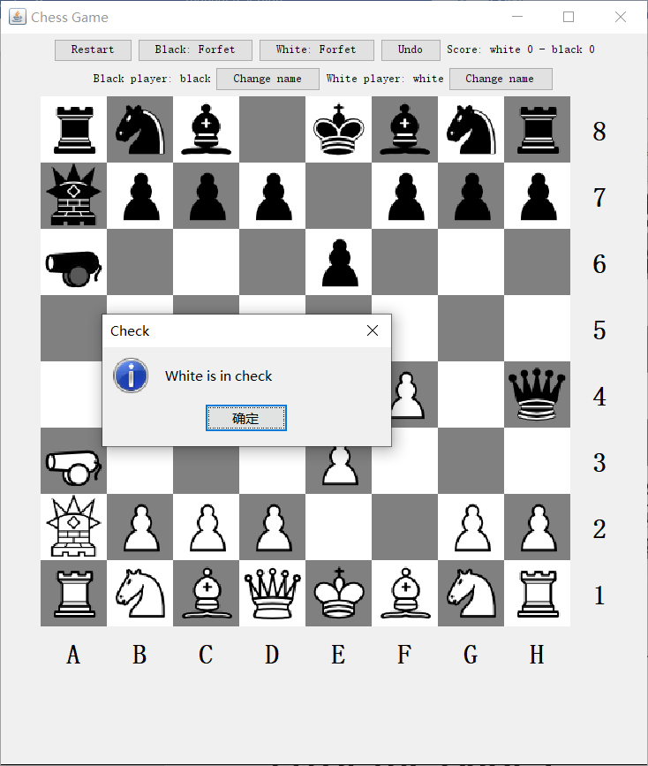

**Error messages**

Image Not Found

The following exception and error message will show up in the console if an image for the piece icons cannot be read. It will also print out your current working directory.

Current working directory : [your working directory]

javax.imageio.IIOException: Can't read input file!

at java.desktop/javax.imageio.ImageIO.read(ImageIO.java:1308)

at chessGame/gui.GUI.<init>(GUI.java:111)

at chessGame/gui.GUI.main(GUI.java:206)

Illegal move

Try to move the pawn at H2 to G3. This is an illegal move, and a pop-up window will show up.

